The settings in the screenshots below are default values and may not be right for you. Make sure everything makes sense before you post process.

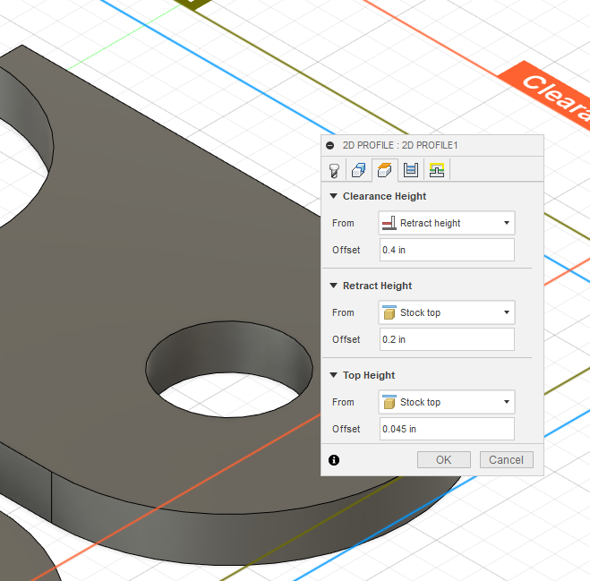

**Clearance Height -** Sets the initial height at which the torch will probe at the start of the run.

**Retract Height -** The height at which the torch will retract to during the job

**Top Height -** Cutting height for the torch.

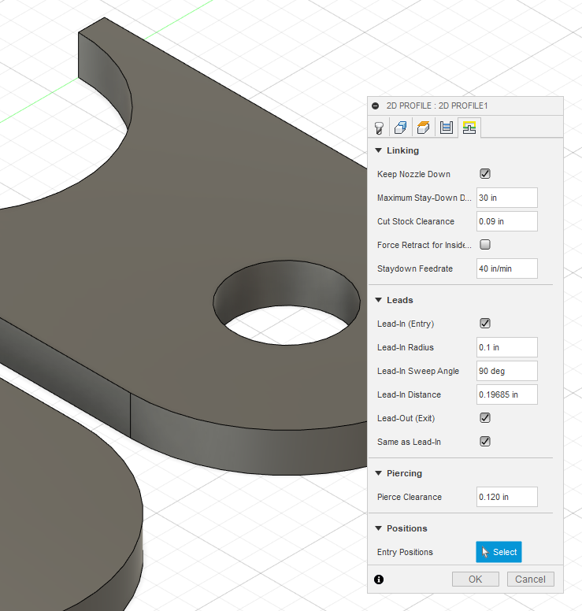

**Pierce Clearance -** Sets the pierce height

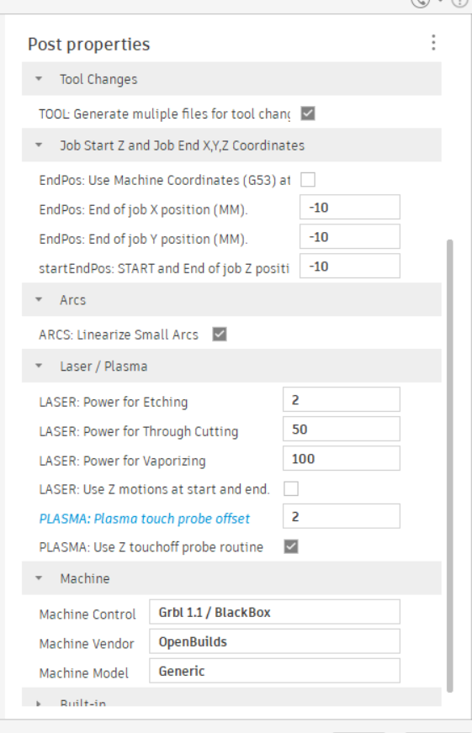

Ensure Z Touch Off Probe Routine is selected and enter your switch offset into Plasma Touch Probe Offset.

If you are having issues with getting your Z-Axis to work use the sample gcode included in the folder to run the job pictured below. The square is 6” and the inside circle is 4”. The Z axis will probe and set the height at the start of each cut.

